10 Way Vertically Mounted Rackmount IEC PDU - UK Sockets (PDU-10WS-V-UK-IEC)

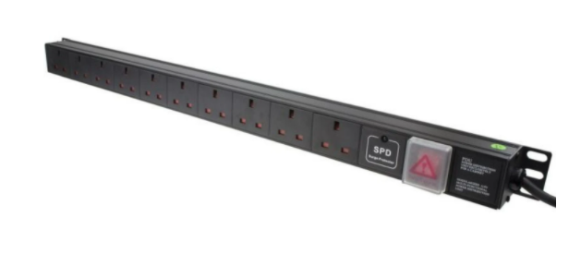

Description:
The LMS Power PDU-10WS-V-UK-IEC is a high-quality vertically mounted PDU (Power Distribution Unit) that simply fits within the universal mounting brackets of data, telecom and server cabinets.
A must-have accessory for your data cabinets if you need to provide effective power to devices including Ethernet Switches, Servers, UPS, NAS and of course cabinet accessories including cooling fan trays.
Robust, alloy design complete with rackmount brackets fitted, high-quality Neon Switch and of course UK output sockets together with a high quality, certified IEC-14 power input plug.

Key Features:

Standard UK 3-Pin power outlets for your appliances

Certified IEC-14 power input plug

1U high means the PDU can fit into the smallest cabinet

Neon On/Off Rocker switch to prevent accidental turn off

Backed up by LMS Power's exclusive 3-year warranty

Applications:
Create instant power feeds to your data, telecom or server cabinets
Provide effective power for cabinet cooling fans, UPS systems
Ideal as stand-alone trailing sockets outside the cabinet

Product Code:
Part Number: PDU-10WS-V-UK-IEC
EAN: 8400800036124
Weight: 1.1Kg approx

Technical Specifications:
Warranty LMS Data 3-Year Warranty
Chassis 1U vertical mount with mounting brackets
Output Sockets 10 UK 3-PIN Sockets
Power Input Fitted IEC-14 Plug
Flex Length 1.8 metres (approx)
Power Control On/Off Rocker Switch (illuminated)
Power Rating 4000 Watts (approx)

Supplied With:
PDU-10WS-V-UK-IEC 10 Way Vertical PDU
19-inch cabinet brackets (Fitted)
* Specifications and product design are subject to change. E&OE.

Looking for highperformance power distribution for your heavily loaded systems? The newly developed LMS Data 10A heavy-duty vertical PDU using the modular IEC-14 input connector which is ideal for many device requirements including server, network and other industrial-type equipment functions such as broadcast and HVAC applications. Combining a fully certified IEC-14 plug input combined with a compatible heavy load power flex means you can be assured this LMS Data PDU can work without problems, 24/7. Furthermore, incorporated onto the vertical form-factor are industry standard UK sockets, ideal for data, telco and broadcast equipment with the added benefit of integral electrical surge protection. Robust in design, with an integral neon illuminated rocker switch for assured functionality, the LMS Data PDU is designed to deliver maximum electrical power today and tomorrow.

specifications:
Vertical, high-density Power Distribution Unit (PDU)
Modular 10A IEC-14 style plug format
Compatible, heavy-load power cable
10x UK output power sockets
Robust, black aluminium design for industrial use
Neon on/off power switch for assured control
Maximum power rating - 4000W
2.0 metre (approx.) power cordage
Ideal for data, telecom, broadcast and HVAC applications

